# Class Exercise 1 Unary relation

* + Employee Jane is Married to Employee John

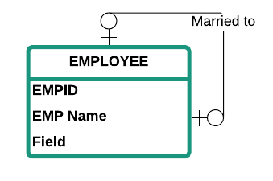

* + Winston Churchill high school team plays against Walt Whitman high school team.

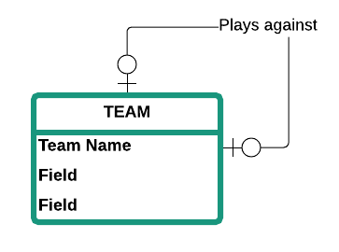

# Class Exercise 2 Binary relation

* + An Employee is assigned a parking space
  + Students registers for Courses

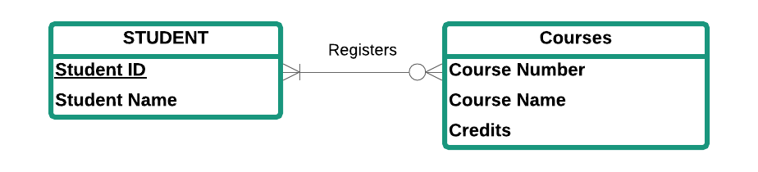

* + A Hotel has many Rooms

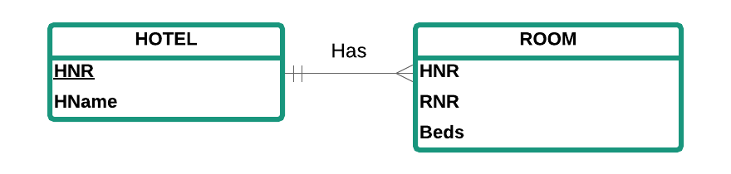

# Class Exercise 3 Ternary relation



